THE LUING CATTLE SOCIETY LTD
`
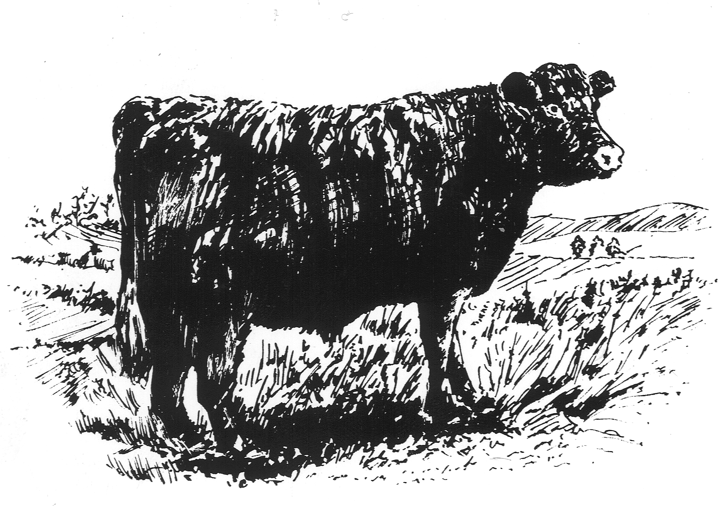

WESTER DRUMLOCHY
LORNTY Tel: 01250 873882
BLAIRGOWRIE
PERTHSHIRE
PH10 6TD e-

e-mail:secretary@luingcattlesociety.co.uk
www.luingcattlesociety.co.uk

31 July 2026

PRESS RELEASE

Record prices at Luing Autumn Sale

All records that stood for the Luing Society’s autumn breeding sale were smashed at the 36th sale held on Saturday 24th October at United Auctions Stirling Agricultural Centre. Pedigree Luing bulling heifers were sold to a top price of £1,800 with a record average of £1,177 – up £475 on the year for 65 sold; in-calf heifers were bid to £2,000 (with an average of £1,680 – up £663 for five sold); in-calf Sim-Luings were bid to £2,200 (£1,988 – up £398 for eight sold) and Sim-Luing bulling heifers sold to £1,500 (£1,071 – up £364 for 28 sold). There was once again a total clearance of the 122 forward.

A total of 65 pedigree bulling heifers sold with the top price of £1,800 paid by Alastair MacArthur, Nunnerie for a pair of 18-month old heifers from William Graham & Son of Craigdarroch, Sanquhar. These polled red heifers were by the homebred bull Craigdarroch Hakka; one was out of a homebred cow and the other a Luing Ardlarach cow. The Graham’s had a memorable sale taking the highest average of £1,320 for 15 heifers sold as well as the top price. Other notable averages for pedigree bulling heifers were the Upper Chatto pen brought out by Stephen Little of the Honourable R.B. Loder Children’s Settlement who sold seven to average £1,271. Angus Kennedy of the Mitchellhill herd followed on from the strong Craigdarroch trade to sell his offering of seven for an average of £1,228. Then came a much sought-after entry of 27 heifers from Cadzow Brothers, Luing, which maintained the strong trade to average £1,168. R.H. Bell & Co. of Plenderleith Luings, Kelso sold three to average £1,100.

The pair of top priced in-calf pedigree Luing heifers came from R.J. Wotherspoon of Glen Lyon and brought out by Farm Manager John Buglass were purchased by David MacRae of the Coulshill Luing herd at Auchterarder. The two heifers were by Wooplaw Eriboll and out of a homebred cow and a Luing cow respectively and due to calve to Wooplaw Breeze next spring. The Glen Lyon herd sold four such in-calf heifers to average £1,700. These in-calf heifers were followed by a single from Angus Kennedy that was knocked down for £1,600.

The highest price of the sale was paid for a pair of registered summer 2007-born Sim-Luing heifers in calf to a Limousin bull from Robert McNee Ltd. at Armadale. This pair of heifers sold for £2,200 to M. Rankin of Kilmaluag, Isle of Skye and were by two Dirnanean Simmental bulls and out of home-bred Benhar cows. The Benhar pen of in-calf Sim-Luings proved extremely popular with eight forward selling to average £1,987. Colin Little from East Bracklinn sold five unregistered Simmental cross Luing in-calf heifers to a top of £1,800 to average £1,680.

Registered Sim-Luing bulling heifers went to £1,500 for a group of three from Messrs D&A Barr of Milkieston, Peebles and were purchased by Messrs W&J Anderson of Strathdon. The Milkieston pen achieved the best average in this section of the sale of £1,440 for five forward. That top price, thought to be a record for cross-bred bulling heifers sold by United Auctions, of £1,500 had been set earlier by a pair of Buckholm Sim-Luings from Wilbert Girvan purchased by R Leiper & Co. of Ponetland, Newcastle. The Bulkholm consignment had an excellent average of £1,173 for 13 forward. Other notable averages included D&L Steel of Mayrock Luings, Kinross who were selling for the first time and achieved an average of £916 for three forward. J Fawcett of Merkland, Dumfriess-shire sold six to average £733. Six Luing cross bulling heifers were also on offer and topped at £850 for an 18mth ¾ Luing ¼ Simmental heifer from William Graham & Son of Craigdarroch. John MacPherson of Blarghour, Dalmally sold four unregistered Simmental cross Luing bulling heifers to average £760.

Commenting on the very strong trade, Society Chairman Matthew Mauchlen said, “Today’s sale has shown the strong underlying confidence in the high quality purebred Luing or Sim-Luing first cross cattle as breeding cows. At a time when numbers of hill and upland cows appear to be falling, the demand for Luing and Sim-Luing stock is rising. We are seeing this with registrations increasing year on year within the Society. This can be attributed to the pull factor from commercial beef farmers wishing to invest in productive female genetics that deliver longevity, sound temperament and health; all traits that our members have long-since dedicated themselves to producing for their customers.”

Ends

Further Information

Johnny C. Mackey
Breed Secretary
Luing Cattle Society Ltd.
Wester Drumlochy, Lornty
Blairgowrie, Perthshire, PH10 6TD

Tel: 01250-873882
Email: secretary@luingcattlesociety.co.uk

